计算机图形学第二次作业
李博杰 PB10000603

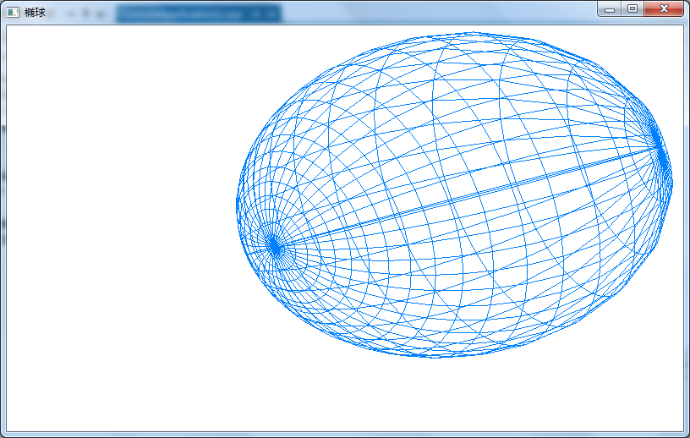

#include "stdafx.h"
#include <gl/glut.h>
#include <math.h>

#define pi 3.1415926
typedef struct Point3f
{
GLfloat x;
GLfloat y;
GLfloat z;
} point;

void setPoint2(GLfloat rx, GLfloat ry, GLfloat rz, GLfloat a, GLfloat b, point* p)
{
p->x = rx*sin(a*pi/180.0)*cos(b*pi/180.0);
p->y = ry*sin(a*pi/180.0)*sin(b*pi/180.0);
p->z = rz*cos(a*pi/180.0);
}
point* getPointMatrix2(GLfloat rx, GLfloat ry, GLfloat rz, GLint slices)
{
int i,j,w=2*slices,h=slices;
float a=0.0,b=0.0;
float hStep=180.0/(h-1);
float wStep=360.0/w;
point *matrix = (point *)malloc(w*h*sizeof(point));
if (!matrix)
return NULL;
for(a=0.0,i=0; i<h; i++,a+=hStep)
for(b=0.0,j=0; j<w; j++,b+=wStep)
setPoint2(rx, ry, rz, a, b, &matrix[i*w+j]);
return matrix;
}

void drawSlice(point &p1, point &p2, point &p3, point &p4)
{
glBegin(GL_LINE_LOOP);
glVertex3f(p1.x,p1.y,p1.z);
glVertex3f(p2.x,p2.y,p2.z);
glVertex3f(p3.x,p3.y,p3.z);
glVertex3f(p4.x,p4.y,p4.z);
glEnd();
}

bool drawOval(GLfloat rx,GLfloat ry,GLfloat rz,GLint slices)
{
int i,j;
int w=2*slices, h=slices;
point *mx = getPointMatrix2(rx,ry,rz,slices);
if(!mx)
return false;
for(i=0; i<h; i++)
for(j=0; j<w; j++)
drawSlice(
mx[i*w + j],
mx[i*w + (j+1)%w],
mx[((i+1)%h)*w + (j+1)%w],
mx[((i+1)%h)*w + j]
);
free(mx);
return true;
}
void drawOval() {
glClear(GL_COLOR_BUFFER_BIT | GL_DEPTH_BUFFER_BIT);
glColor3f(0.0, 0.5, 1.0);
glMatrixMode(GL_MODELVIEW);
glLoadIdentity();
glTranslatef(0.0, 0.0, -25.0);
glRotatef(40.0, 0, 1, 1);
drawOval(6,9,18,20);
glFlush();
}

void initGL(GLfloat width, GLfloat height )
{
glShadeModel(GL_SMOOTH);
glClearColor(1.0, 1.0, 1.0, 0.0);
glMatrixMode(GL_PROJECTION);
glViewport(0, 0, width, height);
gluPerspective(60.0, width/height, 1.0, 100.0);
}

int _tmain(int argc, _TCHAR* argv[])
{
glutInit(&argc, (char **)argv);
glutInitDisplayMode(GLUT_RGB | GLUT_SINGLE);
glutInitWindowPosition(50, 100);
glutInitWindowSize(800, 480);
glutCreateWindow("椭球");
initGL(800,480);
glutDisplayFunc(drawOval);
glutMainLoop();
return 0;
}

